**Help Your Child Get Ready for School**

* Start daily routines such as regular meals and bedtimes.
* Let your child practice doing things on their own such as getting dressed, washing hands, and brushing teeth.
* Set up playdates with other children.
* Let them spend time with other safe adults on occasion.
* Encourage child to try new things.
* Talk about feelings and let them know they are okay.
* Read, talk, sing, and play with your child daily.
* Contact your child’s doctor for vaccinations.

**Home to School Success**

* Talk about school in positive ways.
* Contact the school and enroll your child.
* Visit your child’s school.
* Visit your child’s bus stop and talk about the children getting on and off the bus to go to school and drive the route to school.
* Participate in community programs to support continued learning with you and your child.

**Help Your Child Learn Important Skills**

***I Can...***

* Jump, hop, climb, throw, and balance on one leg
* Cut with scissors, draw, and write with different objects
* Recognize my name in print
* Write my name
* Talk in complete sentences
* Identify the names of letters
* Say the sounds of letters
* Identify the first sound in a word
* Sit and listen to a book that is read to me
* Retell some of a story
* Count objects to 10
* Identify how many is in a group of five or less
* Work at solving a problem on my own
* Be curious and get excited about learning new things

2020-2021

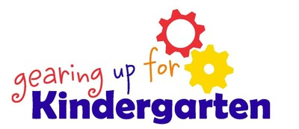

Resources:

<https://www.cdc.gov/coronavirus/2019-ncov/community/schools-childcare/schools.html>

<https://services.aap.org/en/pages/2019-novel-coronavirus-covid-19-infections/clinical-guidance/covid-19-planning-considerations-return-to-in-person-education-in-schools/>

**What to Expect due to COVID-19**

* Bring your own water bottle
* Bring lunches and snacks if possible
* Possible face masks
* Small classroom size with children staying with one teacher as much as possible
* Staggered drop-offs and pick-ups
* Limiting of parents inside the school building
* Bussing: 1 child per seat, masks may need to be worn
* Keep your child home if s/he is sick